Azure End-to-End ETL

Capstone Project

Introduction
This project demonstrates the creation of an end-to-end ETL (Extract, Transform, Load) data pipeline using cloud technologies. The solution is built using Microsoft Azure, where raw data is first stored in Azure Blob Storage and then processed through a pipeline created in Azure Data Factory. The data is cleaned and transformed before being stored as a curated dataset that can be used for analysis. Finally, the processed data is visualized through a dashboard created in Power BI Desktop to generate insights from the dataset. This project highlights how cloud-based tools can be used together to build a simple but effective data engineering workflow.
Screenshots of the different steps of the project have been captured in subsequent sections.

Data Description
The dataset used in this project is a small retail sales dataset in CSV format. It contains transactional sales data including product name, category, quantity, price, region, and order date. The dataset was selected because it allows simple analysis of sales performance across products, regions, and time. The original file (sales_raw.csv) was uploaded directly to the raw container in Azure Blob Storage before any transformations were applied.

Figure 1 Creation of Project Resource Group
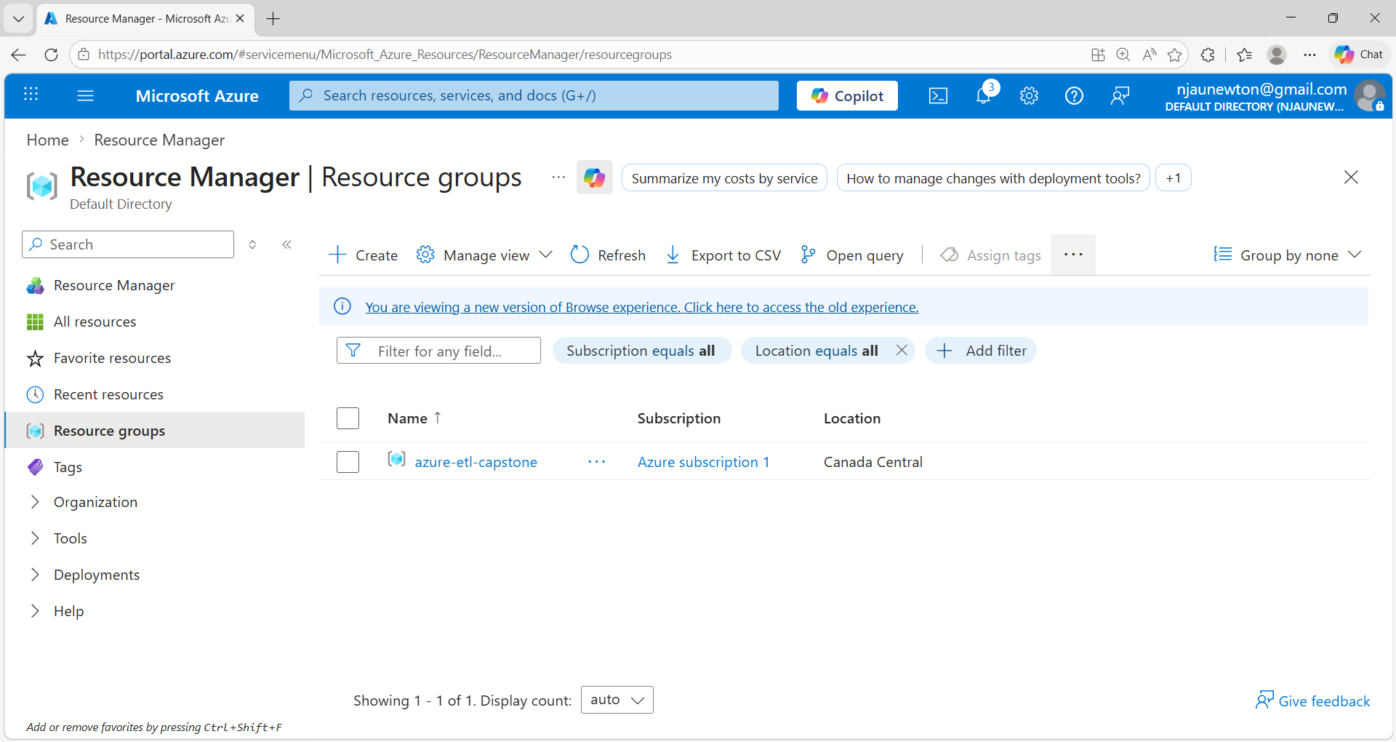
Creation of the azure-etl-capstone Resource Group in Microsoft Azure to organize and manage all cloud resources used in the ETL Capstone Project.

Figure 2 — Storage Account Creation
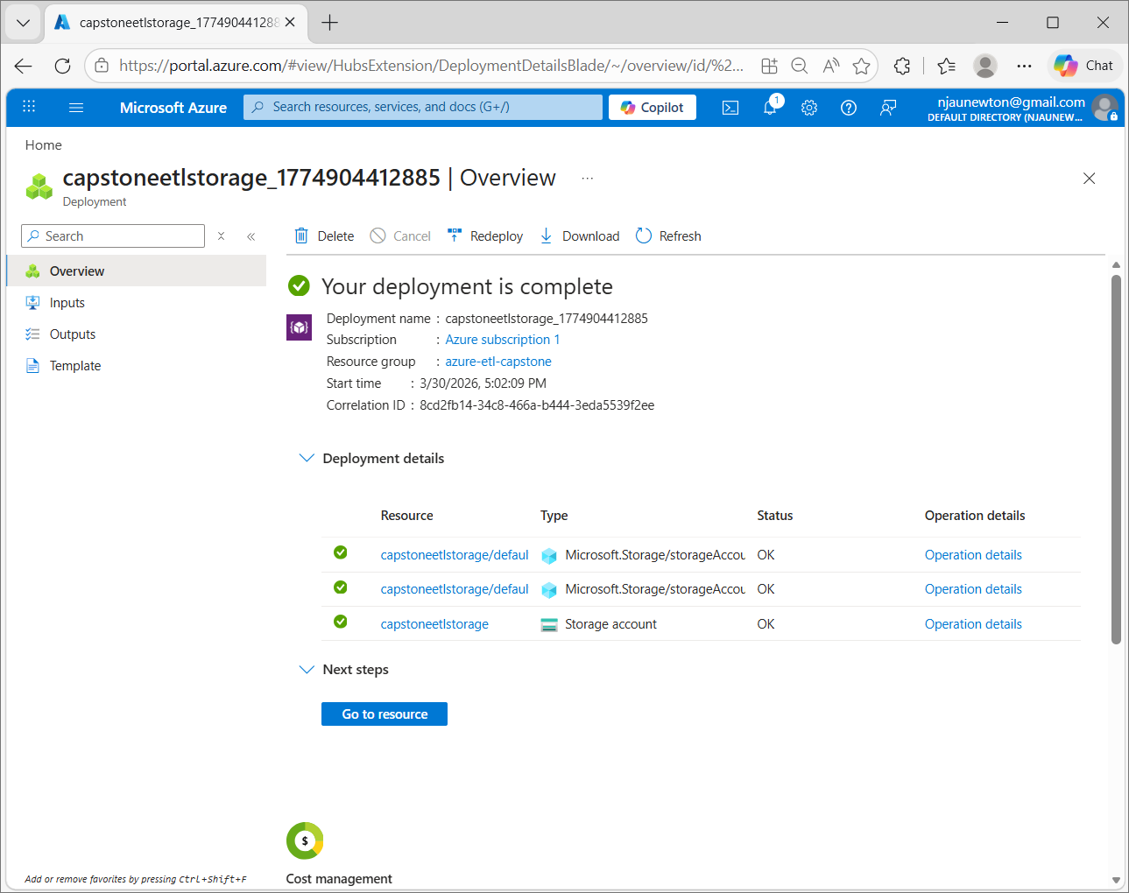
Successful deployment of the storage account in Microsoft Azure for storing raw and processed data used in the ETL pipeline.

Figure 3 — Blob containers (raw and curated)
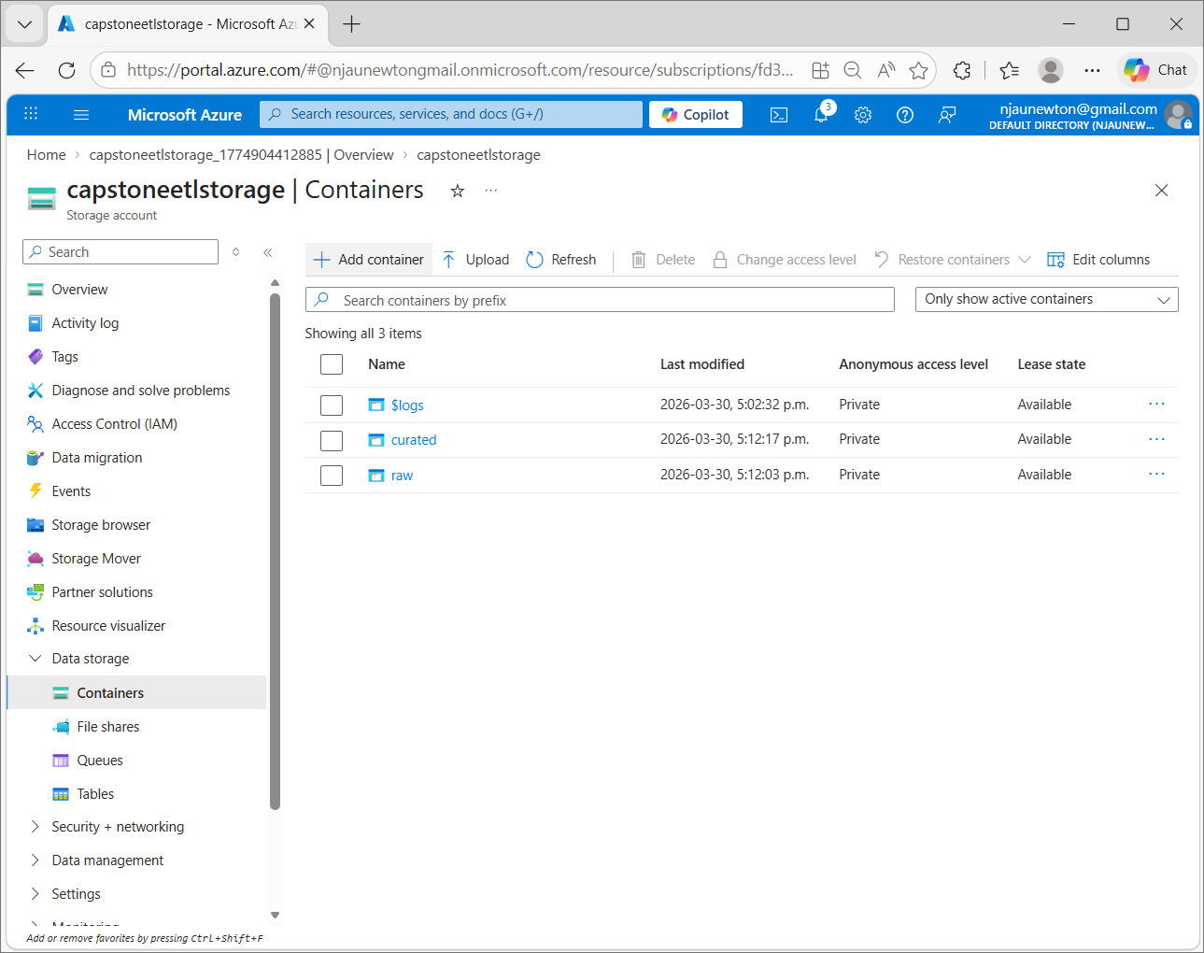
The storage account contains two Blob containers: raw, which stores the original dataset, and curated, which stores the processed and cleaned data that is prepared for analysis.

Figure 4 — Dataset upload
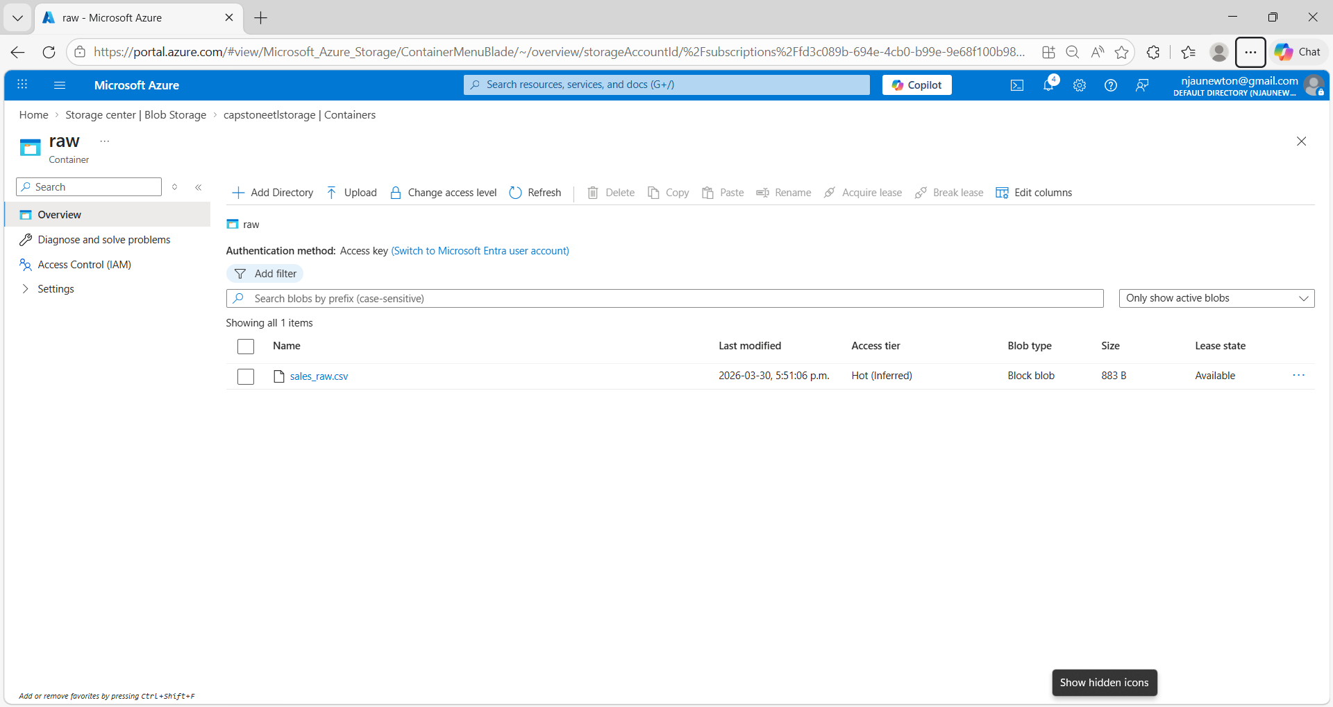
The raw dataset, sales_raw.csv, was uploaded to the raw container in Azure Blob Storage as the first step of the ETL pipeline.

Figure 5 —Data Factory Creation
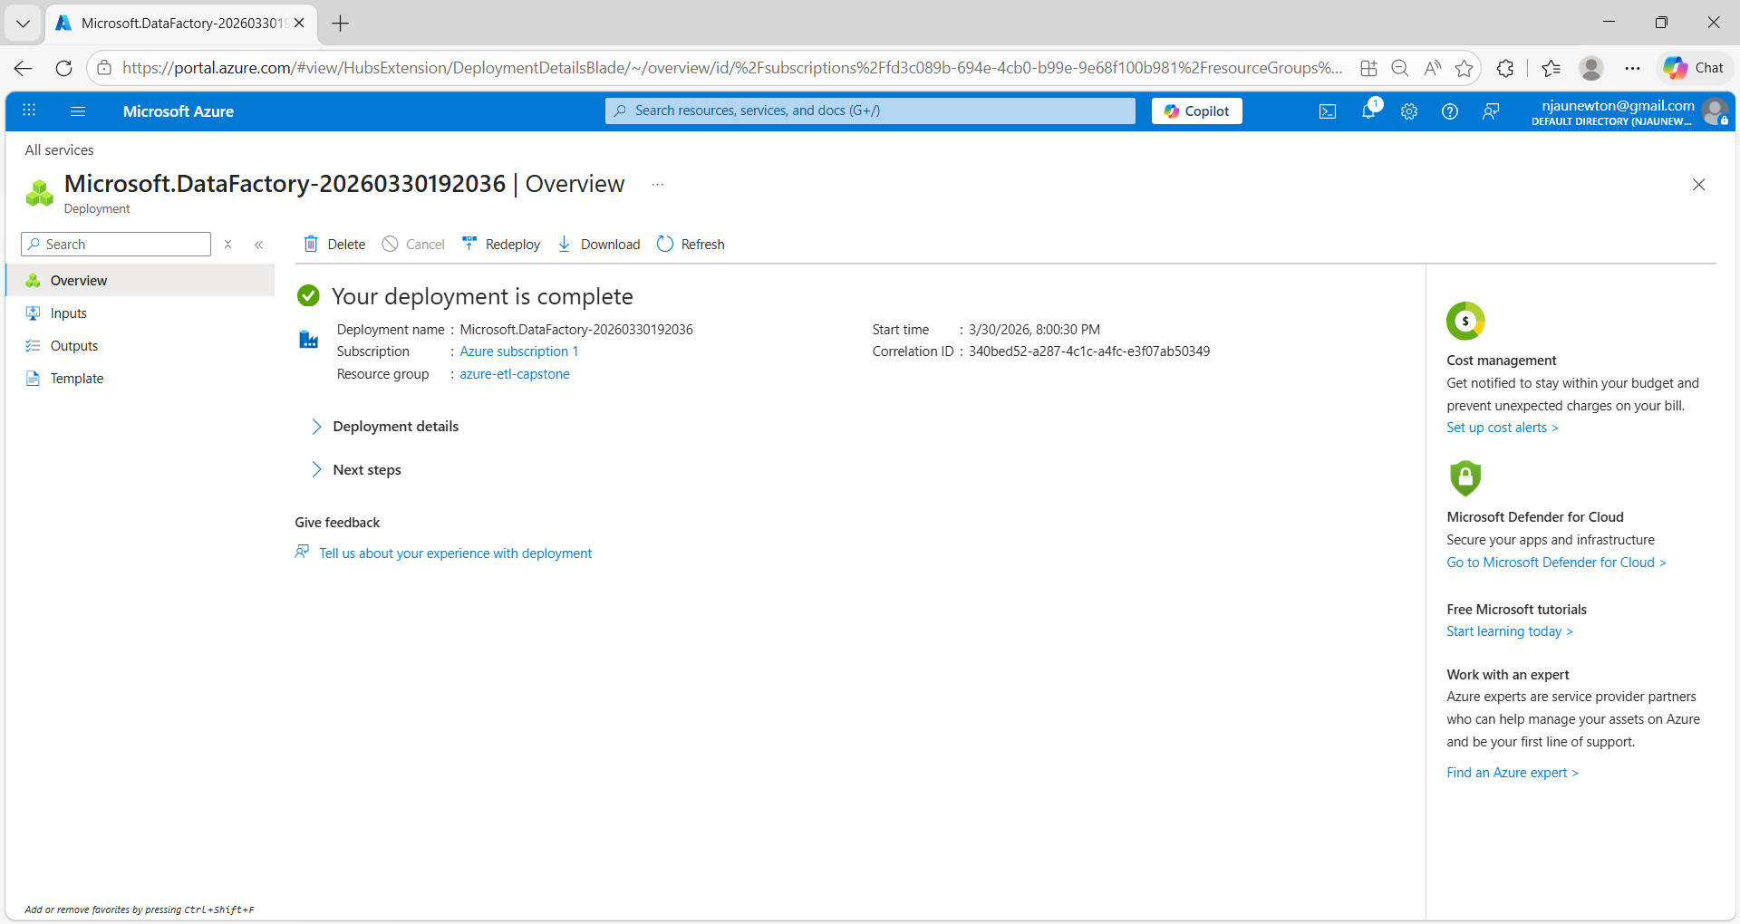
ETL (Extract, Transform, Load) is a data integration process used to extract raw data, transform it into a clean and structured format, and load it into a destination system for analysis. ETL was undertaken on the data with the aim of building a pipeline in Azure Data Factory.

Figure 6 — Creation of Linked Services
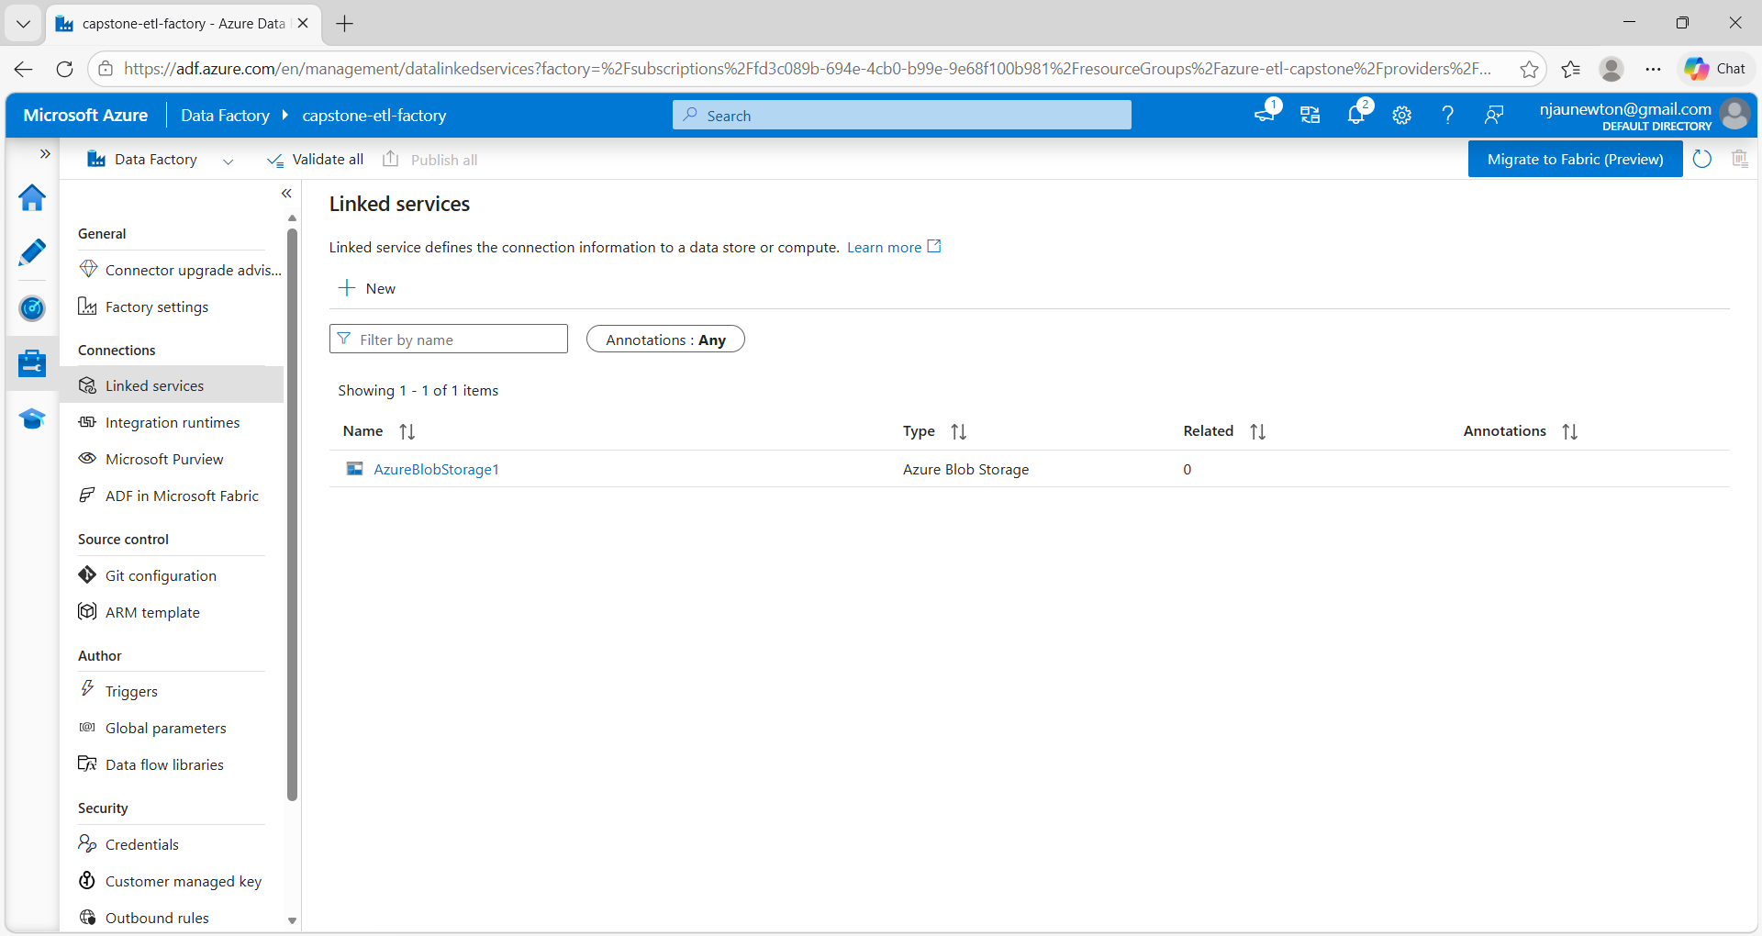
This step involved creation of a linked service connecting Azure Data Factory to Azure Blob Storage for accessing datasets used in the ETL pipeline.

Figure 7 — Creation of the raw dataset
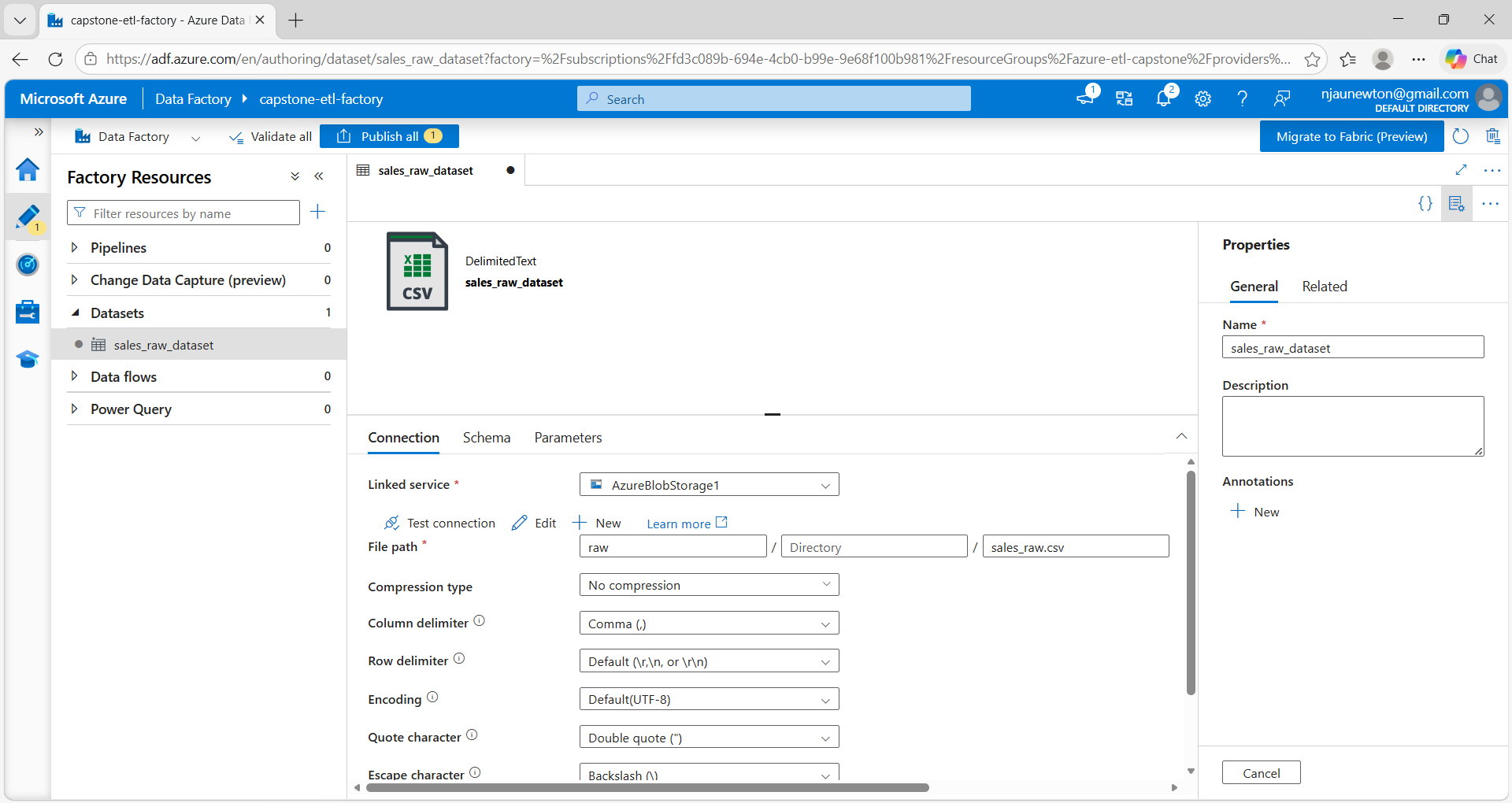
Creation of the raw dataset in Azure Data Factory referencing the source file stored in Azure Blob Storage, which tells Azure Data Factory exactly where the data is and its format.

Figure 8 — Creation of curated dataset
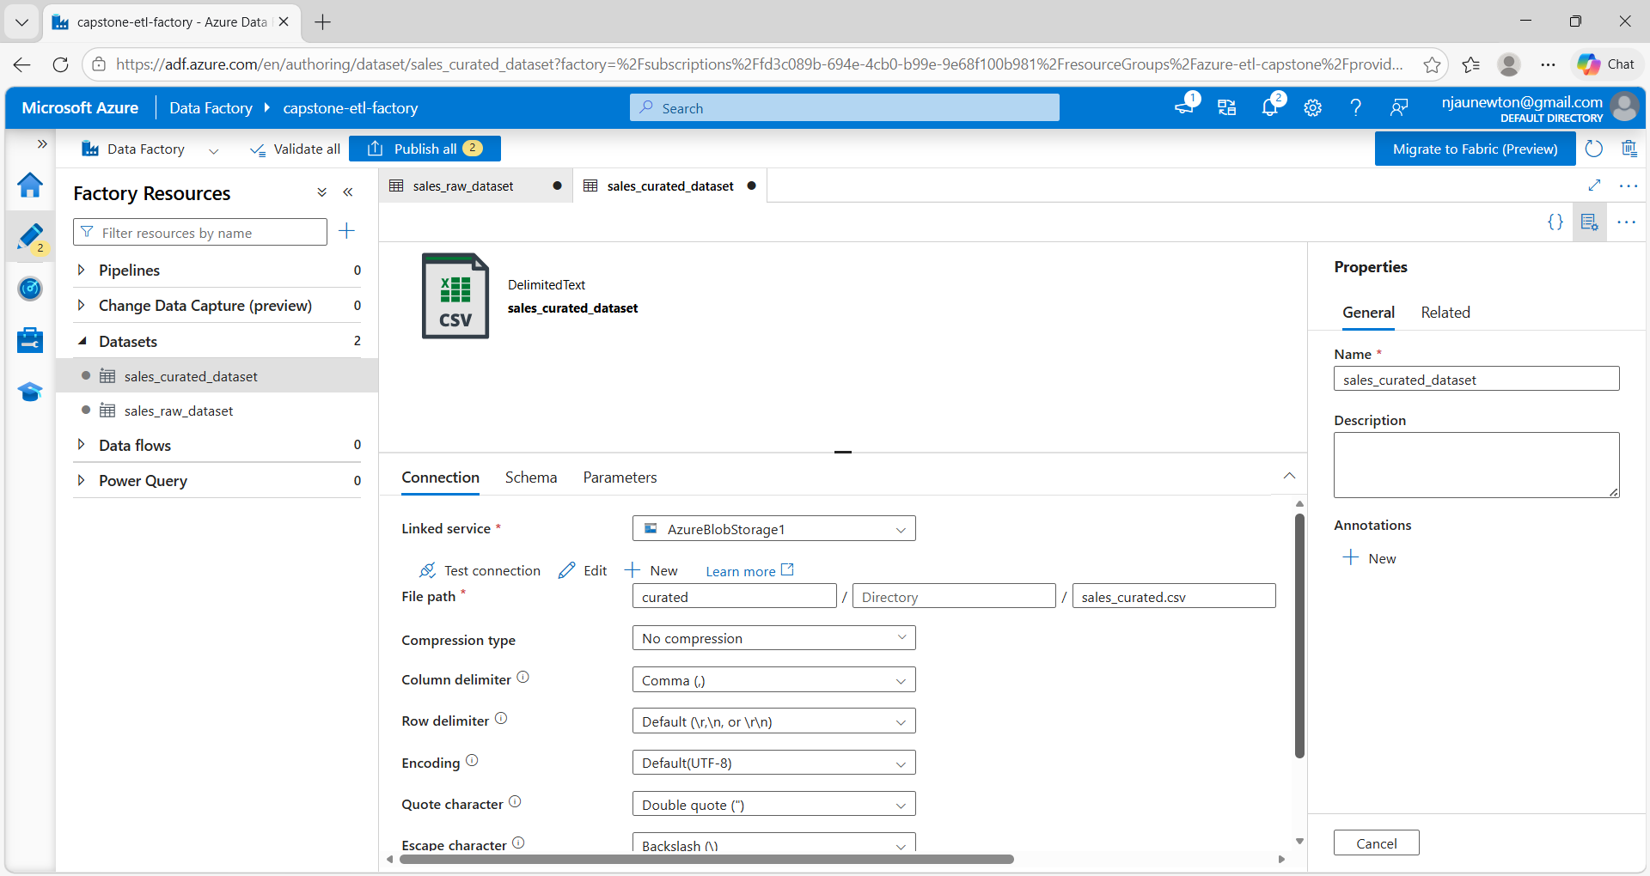
Creation of the curated dataset in Azure Data Factory representing the destination location for the transformed data in Azure Blob Storage.

Figure 9 — Execution of the ETL pipeline
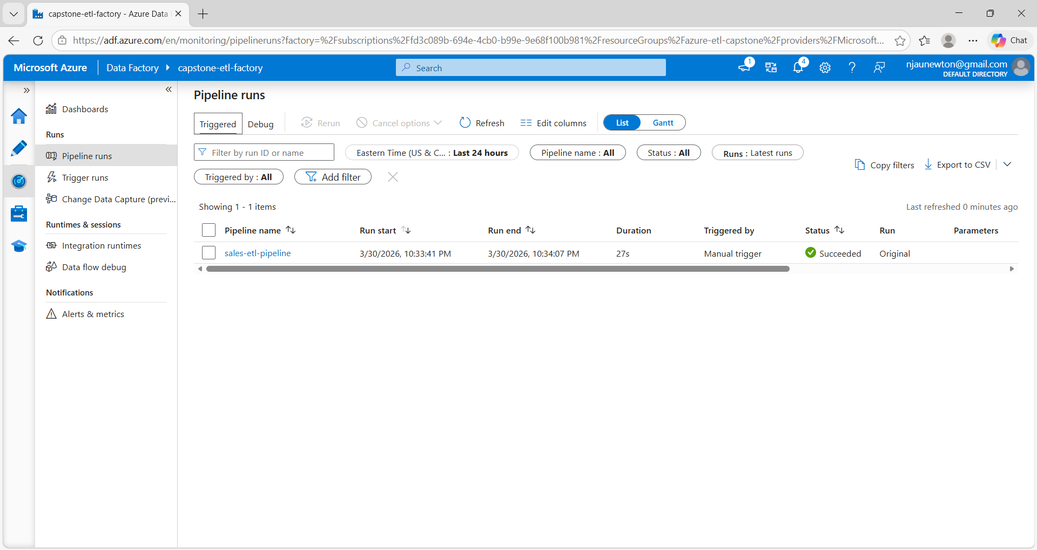
This process involved execution of the ETL pipeline in Azure Data Factory transferring data from the raw container to the curated container in Azure Blob Storage. During the transformation stage, the dataset was validated and prepared for analysis. The curated dataset structure enables calculation of sales metrics such as total revenue using the fields Quantity and Price within Power BI.

Figure 10 — Curated output
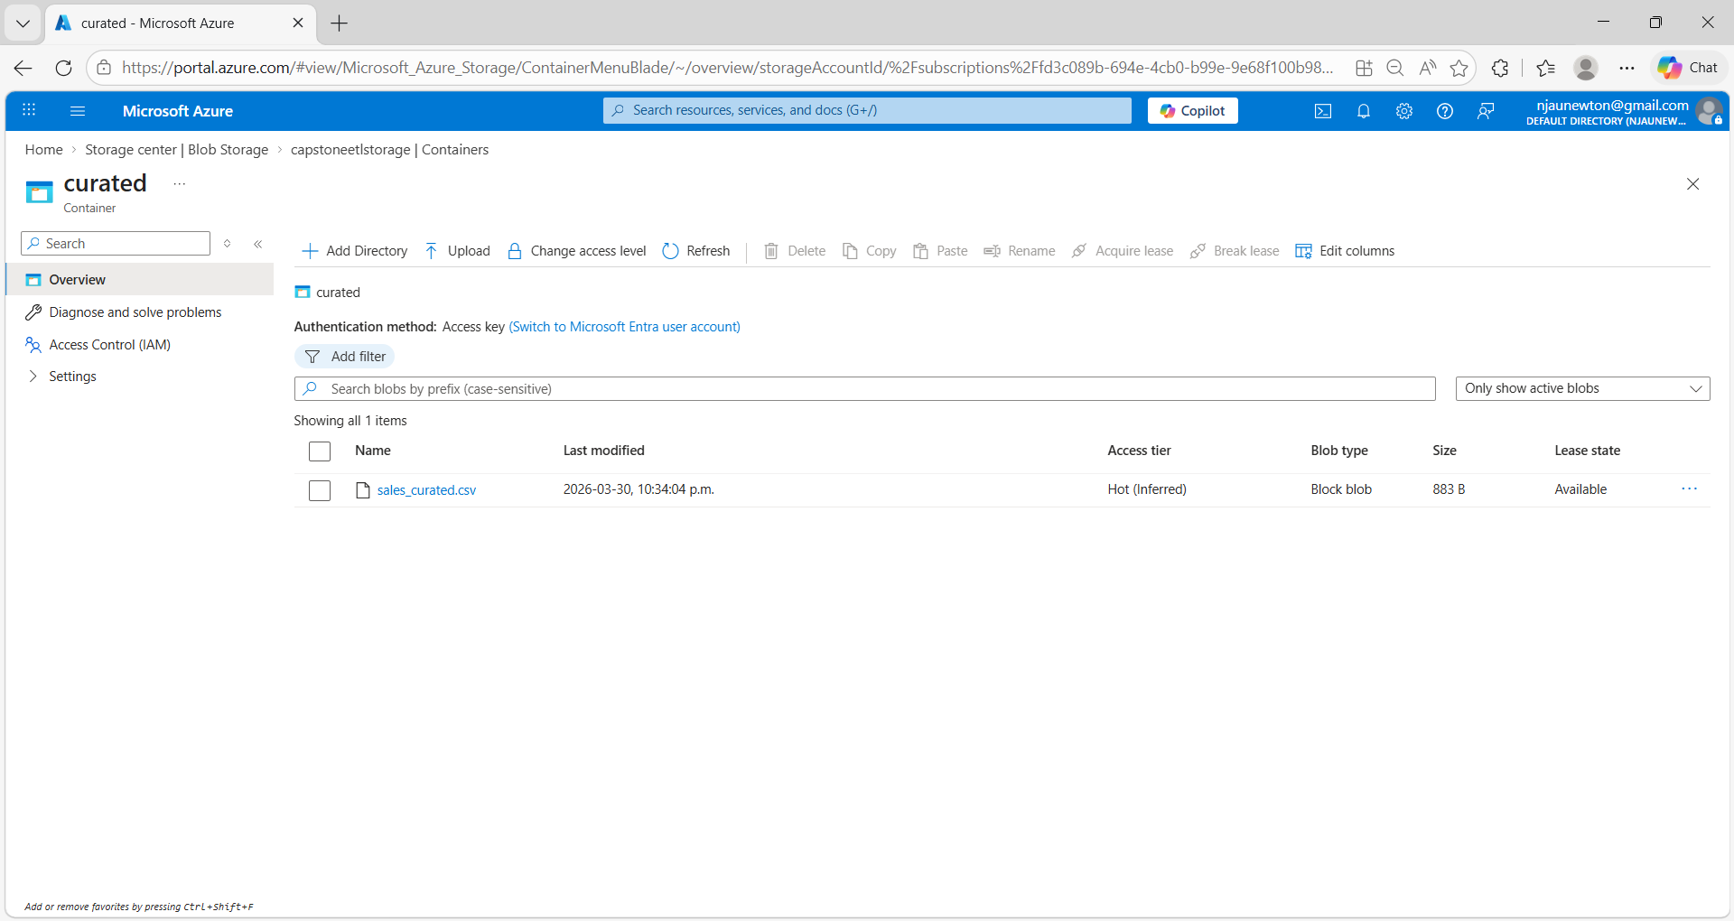
This output shows the output dataset generated by the ETL pipeline and stored in the curated container in Azure Blob Storage after execution of the pipeline in Azure Data Factory.

Figure 11 — Azure activity log
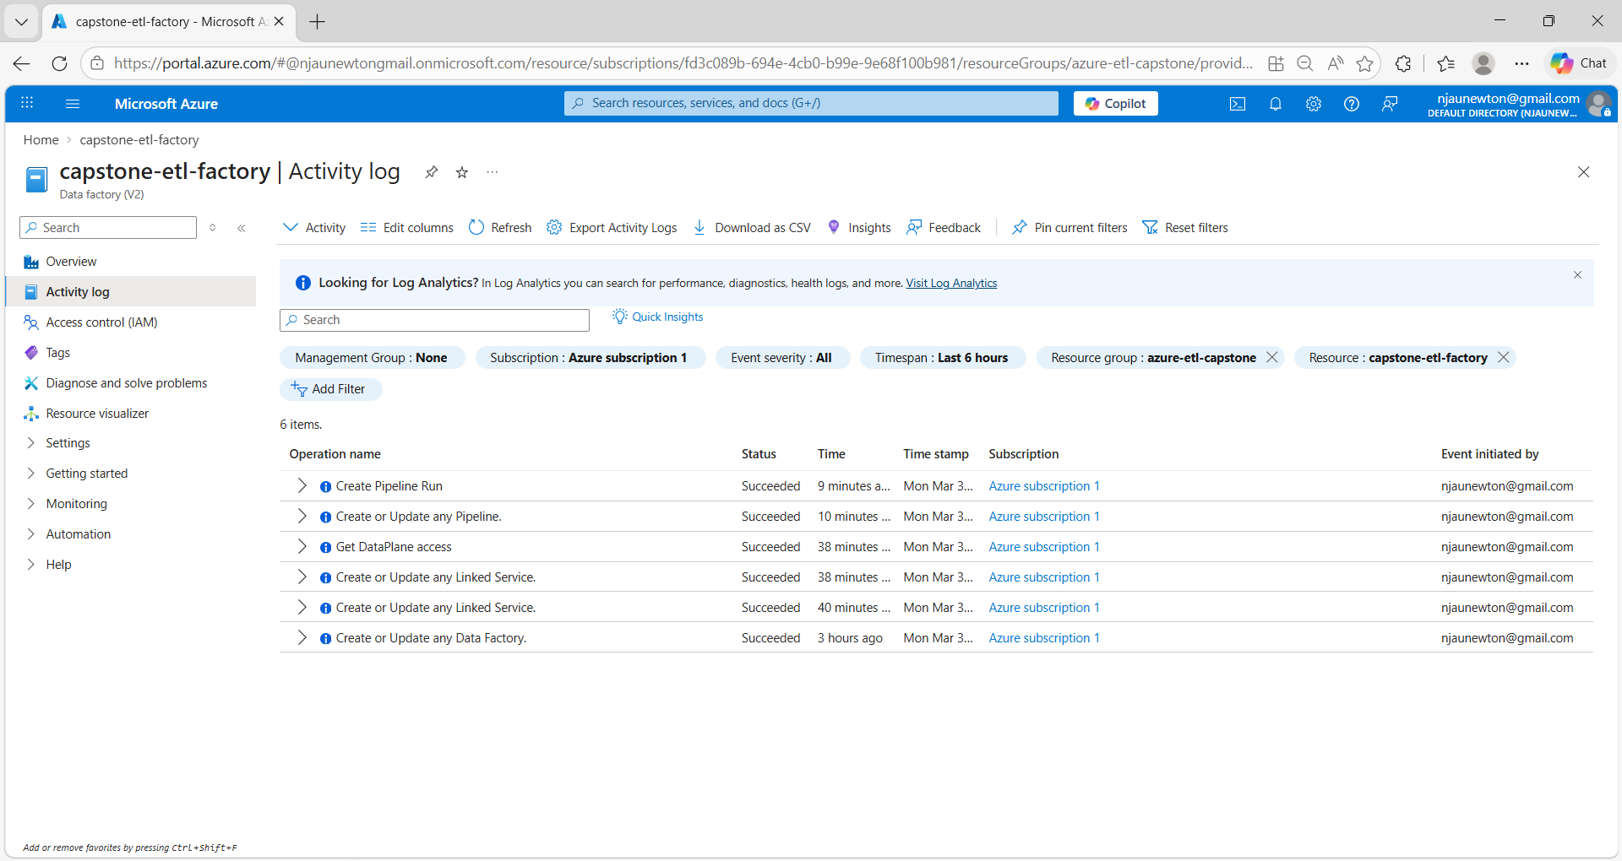
Azure activity log confirming successful deployment and execution of ETL pipeline resources.

Figure 12 — Dashboard built in Power BI Desktop
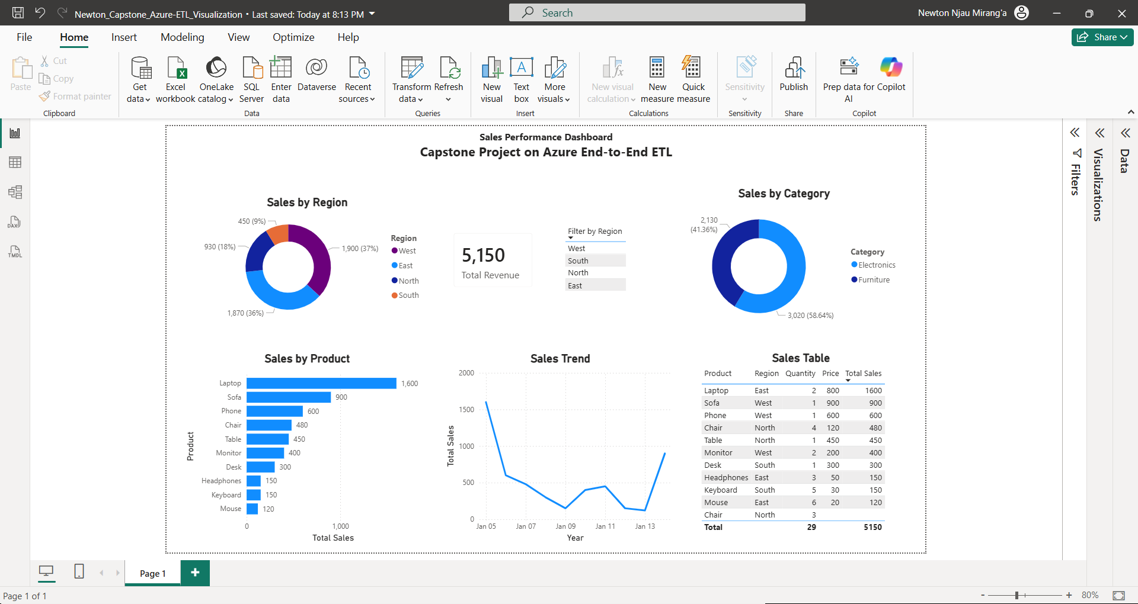
The final Power BI dashboard provides insights into total revenue, product performance, regional sales distribution, and sales trends over time.

Conclusion
This project demonstrated the design and implementation of a cloud-based ETL pipeline using Microsoft Azure. Raw data was first stored in Azure Blob Storage, and an automated pipeline was created using Azure Data Factory to extract the data, process it, and load the transformed dataset into a curated storage container. The solution illustrates how cloud services can be used to build scalable and automated data pipelines for managing and preparing data for analytics.

